[CREATE](http://localhost/phpmyadmin/url.php?url=https://dev.mysql.com/doc/refman/8.0/en/create-procedure.html" \t "mysql_doc) [PROCEDURE](http://localhost/phpmyadmin/url.php?url=https://dev.mysql.com/doc/refman/8.0/en/create-procedure.html) sp\_CreateUsuario( [IN](http://localhost/phpmyadmin/url.php?url=https://dev.mysql.com/doc/refman/8.0/en/comparison-operators.html%23function_in) usua\_codigo int, [IN](http://localhost/phpmyadmin/url.php?url=https://dev.mysql.com/doc/refman/8.0/en/comparison-operators.html%23function_in) usua\_identificacion VARCHAR(50), [IN](http://localhost/phpmyadmin/url.php?url=https://dev.mysql.com/doc/refman/8.0/en/comparison-operators.html%23function_in) usua\_tipodeidentificacion VARCHAR(1), [IN](http://localhost/phpmyadmin/url.php?url=https://dev.mysql.com/doc/refman/8.0/en/comparison-operators.html%23function_in) usua\_nombre VARCHAR(100),[IN](http://localhost/phpmyadmin/url.php?url=https://dev.mysql.com/doc/refman/8.0/en/comparison-operators.html%23function_in) usua\_apellido VARCHAR(50), ,[IN](http://localhost/phpmyadmin/url.php?url=https://dev.mysql.com/doc/refman/8.0/en/comparison-operators.html%23function_in) usua\_celular VARCHAR(50), usua\_direccion VARCHAR(50), usua\_usuario VARCHAR(50), usua\_password VARCHAR(50), id\_rol\_fk, VARCHAR(50),) BEGIN [INSERT](http://localhost/phpmyadmin/url.php?url=https://dev.mysql.com/doc/refman/8.0/en/insert.html) INTO usuarios (código,nombre, apellido, , [password](http://localhost/phpmyadmin/url.php?url=https://dev.mysql.com/doc/refman/8.0/en/encryption-functions.html%23function_password)) [VALUES](http://localhost/phpmyadmin/url.php?url=https://dev.mysql.com/doc/refman/8.0/en/miscellaneous-functions.html%23function_values) (p\_nombre, p\_apellido, ,id\_rol\_fk); END;

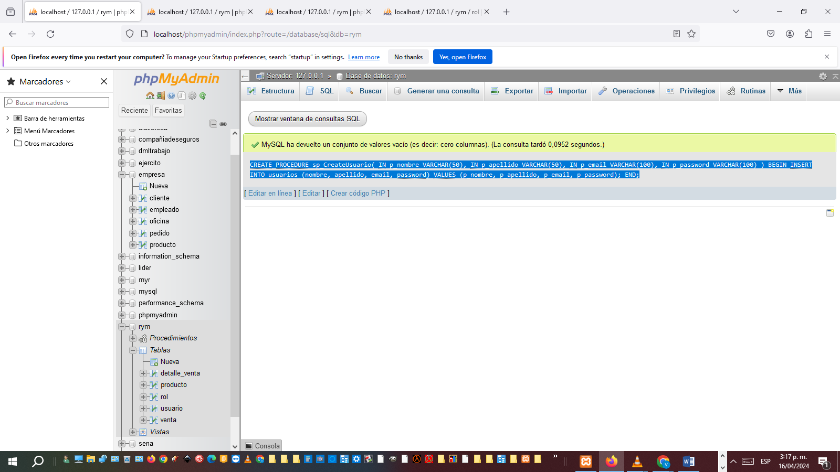

[CREATE](http://localhost/phpmyadmin/url.php?url=https://dev.mysql.com/doc/refman/8.0/en/create-procedure.html) [PROCEDURE](http://localhost/phpmyadmin/url.php?url=https://dev.mysql.com/doc/refman/8.0/en/create-procedure.html) sp\_ReadUsaarioByID( [IN](http://localhost/phpmyadmin/url.php?url=https://dev.mysql.com/doc/refman/8.0/en/comparison-operators.html%23function_in) p\_id INT ) BEGIN [SELECT](http://localhost/phpmyadmin/url.php?url=https://dev.mysql.com/doc/refman/8.0/en/select.html) \* FROM usuario WHERE id = p\_id; END;

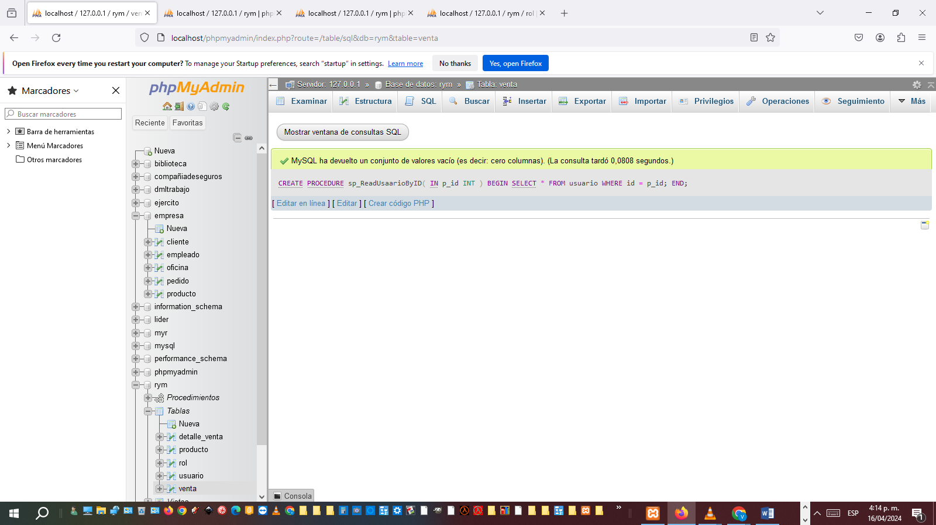

[CREATE](http://localhost/phpmyadmin/url.php?url=https://dev.mysql.com/doc/refman/8.0/en/create-procedure.html) [PROCEDURE](http://localhost/phpmyadmin/url.php?url=https://dev.mysql.com/doc/refman/8.0/en/create-procedure.html) sp\_UpdateUsuario( [IN](http://localhost/phpmyadmin/url.php?url=https://dev.mysql.com/doc/refman/8.0/en/comparison-operators.html%23function_in) p\_id INT, [IN](http://localhost/phpmyadmin/url.php?url=https://dev.mysql.com/doc/refman/8.0/en/comparison-operators.html%23function_in) p\_nombre VARCHAR(50), [IN](http://localhost/phpmyadmin/url.php?url=https://dev.mysql.com/doc/refman/8.0/en/comparison-operators.html%23function_in) p\_apellido VARCHAR(50), [IN](http://localhost/phpmyadmin/url.php?url=https://dev.mysql.com/doc/refman/8.0/en/comparison-operators.html%23function_in) p\_email VARCHAR(100), [IN](http://localhost/phpmyadmin/url.php?url=https://dev.mysql.com/doc/refman/8.0/en/comparison-operators.html%23function_in) p\_password VARCHAR(100) ) BEGIN [UPDATE](http://localhost/phpmyadmin/url.php?url=https://dev.mysql.com/doc/refman/8.0/en/update.html) usuario [SET](http://localhost/phpmyadmin/url.php?url=https://dev.mysql.com/doc/refman/8.0/en/set.html) nombre = p\_nombre, apellido = p\_apellido, email = p\_email, [password](http://localhost/phpmyadmin/url.php?url=https://dev.mysql.com/doc/refman/8.0/en/encryption-functions.html%23function_password) = p\_password WHERE id = p\_id; END;

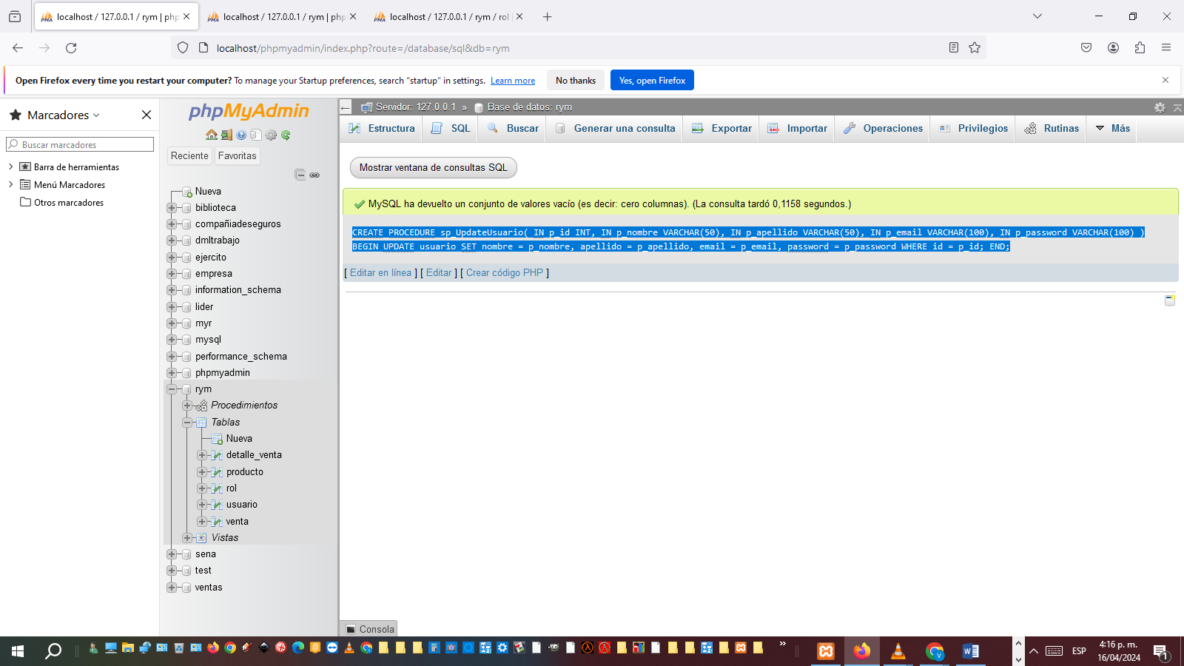

[CREATE](http://localhost/phpmyadmin/url.php?url=https://dev.mysql.com/doc/refman/8.0/en/create-procedure.html) [PROCEDURE](http://localhost/phpmyadmin/url.php?url=https://dev.mysql.com/doc/refman/8.0/en/create-procedure.html) sp\_DeleteUsuario( [IN](http://localhost/phpmyadmin/url.php?url=https://dev.mysql.com/doc/refman/8.0/en/comparison-operators.html%23function_in) p\_id INT ) BEGIN [DELETE](http://localhost/phpmyadmin/url.php?url=https://dev.mysql.com/doc/refman/8.0/en/delete.html) FROM usuario WHERE id = p\_id; END;

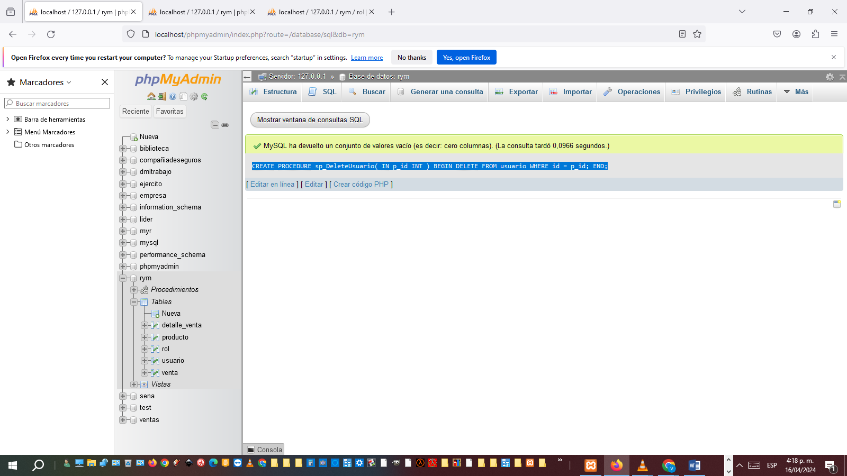

call sp\_CreateUsuario ("12123","1031802280","cc","luis","cardenas","3222659109","calle 184 #8-90","lui23","los30432","1")